**Chapter-14 Higher order functions**

A higher order function is a function that either takes a function as one of its parameters or returns a function or it does both.

For eg: Array.map(), Array.reduce(), setTimeout() and add

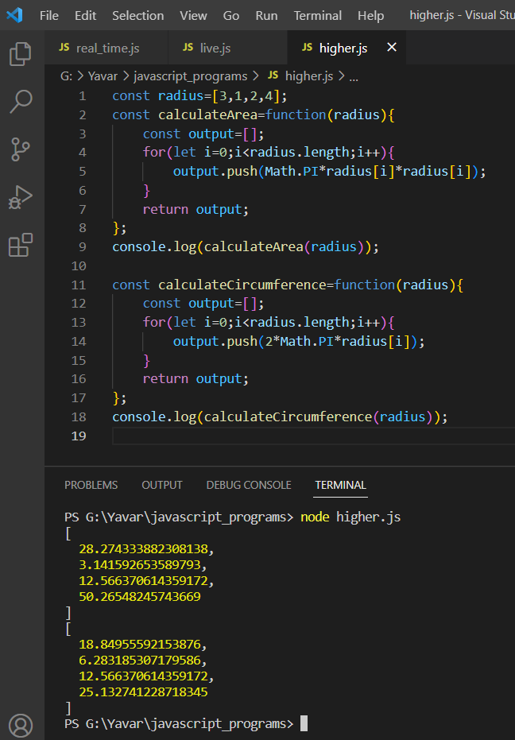

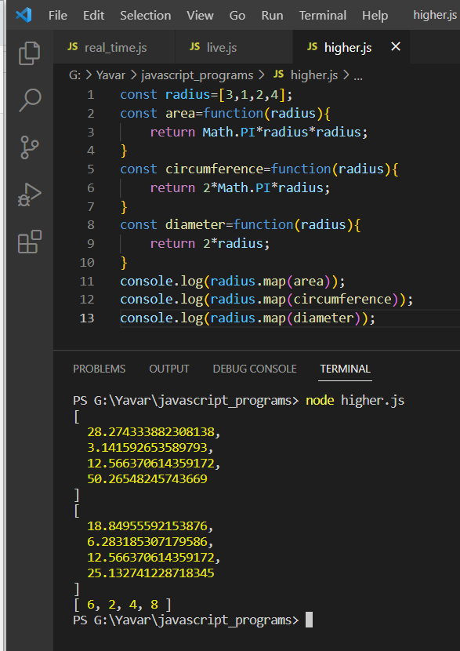

In the first example, for every function area and circumference a for loop is executed to find the area and circumference for all the values in the array. This proess is done by map() function. The iteration is carried out by the map function and for each values the output is calculated. The function area is passed to the map function. Hence it is called the higher order function.